

The Garth Hunt Branch of the Pony Club

OPEN SHOWJUMPING
Saturday 7th November 2026

BERKSHIRE COLLEGE OF AGRICULTURE SL6 6QR

Open to Pony Club Members and
Non-Pony Club competitors

Judge: Sue Darlow


Course Builder: Peter Gillespi

Photography: Paul Tarling | https://www.tt-photography.co.uk/

Catering: Roasted & Toasted

Entries open: Friday 18th September

Entries close: Tuesday 3rd November

Entries | https://garthpc.entrymaster.online/

Times, live scoring and results: Times available from 6.00 pm Thursday 5th November on Pony Club Results www.ponyclubresults.co.uk

Competitor number bibs to be printed from Pony Club Results. Bridle/saddle pad numbers must be worn on both sides.

First Aiders and Paramedic available during competition time.

CLASSES

Classes are open to all, lead rein/assistance only allowed in Classes 1 and 2

CLASS 1 – X POLES

CLASS 2 – 40 cm

CLASS 3 – 50cm

CLASS 4 – PC60

CLASS 5 - PC70

CLASS 6 – PC80

CLASS 7 – PC90

CLASS 8 – PC100

CLASS 9 – PC110

All Classes are single phase

Entry Fee: £20.00 per Class plus £5.00 per person First Aid.

All entries are non-refundable subject to a doctor or vets certificate.

Useful information

- All horses and ponies are required to be vaccinated in line with the Pony Club Rules 2026. We reserve the right to check passports on request. It is a legal requirement to transport your horse with its passport.
- All classes will be held in the indoor arena.
- Numbers in the warm-up area will be limited to 6. Please do not enter the warm-up arena until
you have been invited by the steward.
- All horses/ponies outside of arena/warm-up areas should be ridden in walk to ensure the safety
of all spectators and pedestrians.
- Pony Club Members - Don’t forget your Pony Club Badge, Tie/Stock. Hats must be tagged with
current standard tag (pink). Spurs may only be worn if you have passed your C+ Riding Test or Spurs Test and you must provide proof of this to the organizer upon request. A yellow hat tag must be worn.
- For details about acceptable tack, dress and other guidelines please see relevant Pony Club Rule
Books.
- Start times and numbers will be available from Thursday 5th November on Pony Club Results
- In the event of the event being cancelled refunds will be processed via Entrymaster.
- Refunds (minus £6.50) will only be actioned prior to closing date subject to a doctor’s or vets
certificate.
- Late entries are at the discretion of the organizer and carry an additional £5.00 admin fee.
- Horses/ponies should only be tied outside trailers/lorries if a responsible adult is present.
- Please do not tie hay nets outside of vehicles. You are expected to clear any droppings/hay
from around your parking area.
- Competitors are required to be correctly dressed for prize giving.

Rosettes
- 1st to 6th place
- Prizes 1st – 3rd

Entry amendments
If you need to edit your horse or rider details before the closing date Tuesday 3rd November, please email Garthhuntevents@gmail.com

For all horse and/or rider substitutions after the closing date these must be done via your DC/Centre Proprietor/Branch Secretary/Team manager (on behalf of the DC) and emailed to Garthhuntevents@gmail.com

Rules and Conditions of Entry

Health & Safety:
Organisers of this event have taken reasonable precautions to ensure the health and safety of everyone present. For these measures to be effective, everyone must take all reasonable precautions to avoid and prevent accidents occurring and must obey the instructions of the organisers, officials and stewards.

Legal Liability:
Save for the death or personal injury caused by the negligence of the organisers, or anyone for whom they are in law responsible, neither the organisers of this event or The Pony Club nor any agent, employee or representative of these bodies, nor the landlord or his tenant, accepts any liability for any accident, loss, damage, injury or illness to horses, owners, riders, spectators, land, cars, their contents and accessories, or any other person or property whatsoever. Entries are only accepted on this basis.

Reasonable Adjustment:
The Pony Club is committed to ensuring that, wherever possible, members are able to access all aspects of the Branch and Centre activities we offer. Reasonable Adjustments are any actions that help to reduce the effect of a disability or difficulty. Any requests for Reasonable Adjustment must be made by Tuesday 3rd November. Details of the Pony Club Reasonable Adjustment Policy can be found here:
https://resources.pcuk.org/wp-content/uploads/2023/12/reasonable-adjustment-policy.pdf

Insurance:
All non-members competing at a Pony Club organised event, should have their own Third-Party Liability Insurance.

THE AREA 13 WINTER SHOWJUMPING LEAGUE 2026/2027

The shows included in the League and heights available at each show:

- Saturday 19 September 2026 | Garth South PC at Newbury Show Ground (PC60-PC110)
- Sunday 4 October 2026 | Wokingham PC at BCA (PC60-110)
- Saturday 24 October 2026 | Crawley & Horsham Hunt South at Sands Farm Equitation Centre (PC60-PC90)
- Sunday 25 October 2026 | Hambledon Hunt (North) PC at Crofton Manor Equestrian Centre (PC60-PC110)
- Wednesday 28 October 2026 | Lord Leconfield Hunt PC at Sands Farm Equitation Centre (PC60-PC90)
- Saturday 7 November 2026 | Garth Hunt at BCA (PC60-PC110)
- Sunday 3 January 2027 | Bisley & Sandown Chase PC at Merrist Wood Arena (PC60-PC110)
- Sunday 31 January 2027 | Wokingham PC Area 13 Spring Festival Qualifier at BCA (PC70-PC110)
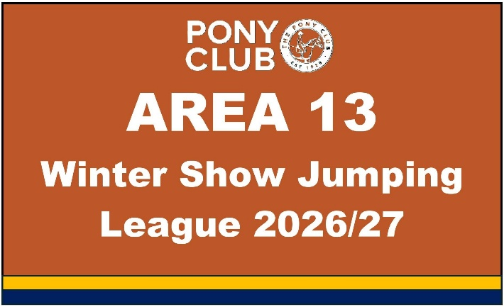
LEAGUE RULES:

- This League is for Area 13 Pony Club Members only and
you must be a current member throughout the League.
- League entry is automatic if you enter for any of the
eligible Area 13 Winter Showjumping League
competitions in classes that are for PC60 – PC110.
- Combinations can earn points in each Class that they
enter – they get 1 point for each Class they participate
in, 1 point for a double clear round and earn additional points if they are in the top 10 combinations i.e. 10 points for 1st place, going down to 1 point for 10th place across all the classes.
- Results for each Combination will be counted from 2 Classes only at each show. Note: Combinations may
compete at more levels if they meet the eligibility criteria on the specific schedule but the results will be taken from the combination’s best 2 rounds on the day.
- Points will be counted from all 8 competitions across all Classes from PC60 – PC110 resulting in one overall
Area 13 Winter Show Jumping League Champion and rosettes are from 1st to 10th place.
- There will also be an Area 13 “Top of the Heights” Winners – a winner rosette will be given to the person
who does the best at each of the 6 competition levels.
- Prize Giving for the Area 13 Winter Show Jumping League will take place on 31 January 2027 at the
Spring Festival Qualifier at BCA.

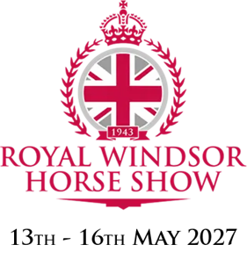
AREA 13 ROYAL WINDSOR HORSE SHOW TICKETS 2027

The top 6 members in the PC110 League will be given one of the Area 13 places to ride at the Royal Windsor Horse Show in the Pony Club 110 Showjumping competition (subject to conditions outlined in the Rules section of this schedule).

Rules & Eligibility:

- Must be a member on date of competition AND for the Windsor date.
- Must have had no more than 16 jumping faults at any of the League competitions.
- RIDER can only qualify for Windsor on one horse. If the rider is placed in the top 6 of the League on more than one horse, they select which one they want to take to Windsor. The Windsor qualification passes down to the next combination in the League assuming they meet the eligibility requirements.
- Reserves will be the next placed combinations from the League competitors providing they fulfil the criteria set out in these Rules.
- Riders who have represented Area 13 at Windsor Showjumping on TWO or more previous occasions will not be eligible to qualify for the current year.
- THIS IS SUBJECT TO AN INVITATION BEING ISSUED TO AREA 13 TO TAKE PART IN THE PONY CLUB COMPETITION AT THE ROYAL WINDSOR HORSE SHOW.

